CSA0504(Data base management system) M.Keerthi
CO1 ASSESSMENT TOOL - 2 (1925255243)

Q1. Construct a concept map linking the following terms: DBMS, Schema, Instance, Data Model, ER Diagram, Entity, Attribute, Relationship.

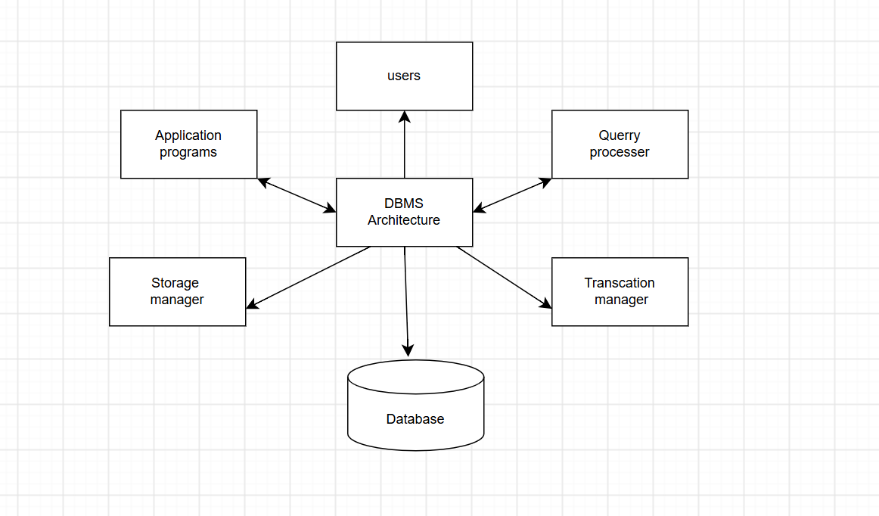
DBMS
- Manages databases
- Stores, retrieves, updates data
- Provides security and backup
Data Model
- Defines the structure of data
- Types:
  - Hierarchical Model
  - Network Model
  - Relational Model
Schema
- Blueprint of the database
- Defines tables, attributes, and relationships
- Changes rarely
Instance
- Actual data stored in the database
- Changes frequently
ER Diagram
- Graphical representation of database
- Used for database design
Entity
- Real-world object
- Example: Student, Employee
Attribute
- Property of an entity
- Example: Student_ID, Name, Age
Relationship
- Association between entities
- Example: Student enrolls in Course

Q2. Create a concept map for the three-level ANSI/SPARC architecture showing data independence at each level.
External Level
- User View
- Different users have different views
↓
Logical Data Independence
- Changes in conceptual schema do not affect external views
↓
Conceptual Level
- Overall logical structure
- Contains entities, relationships, constraints
- Physical Data Independence
- Changes in storage do not affect conceptual schema

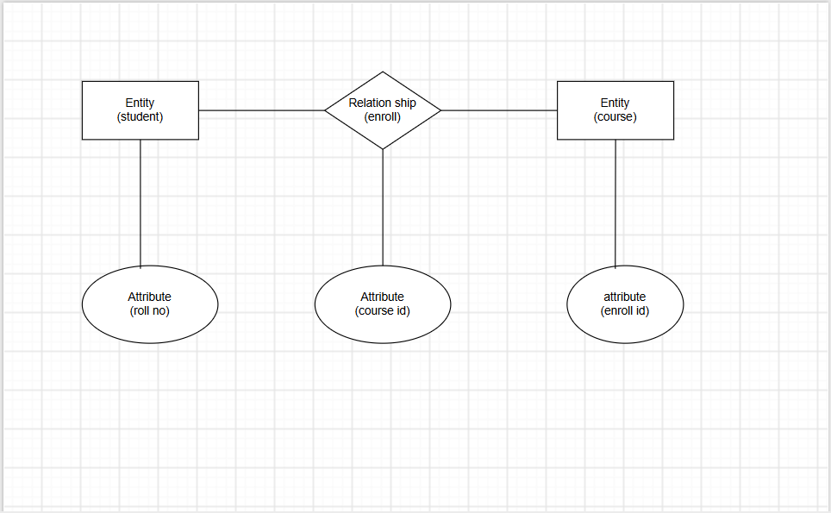

Q3. Map the relationship between file-based systems and database systems, highlighting the problems solved by DBMS.

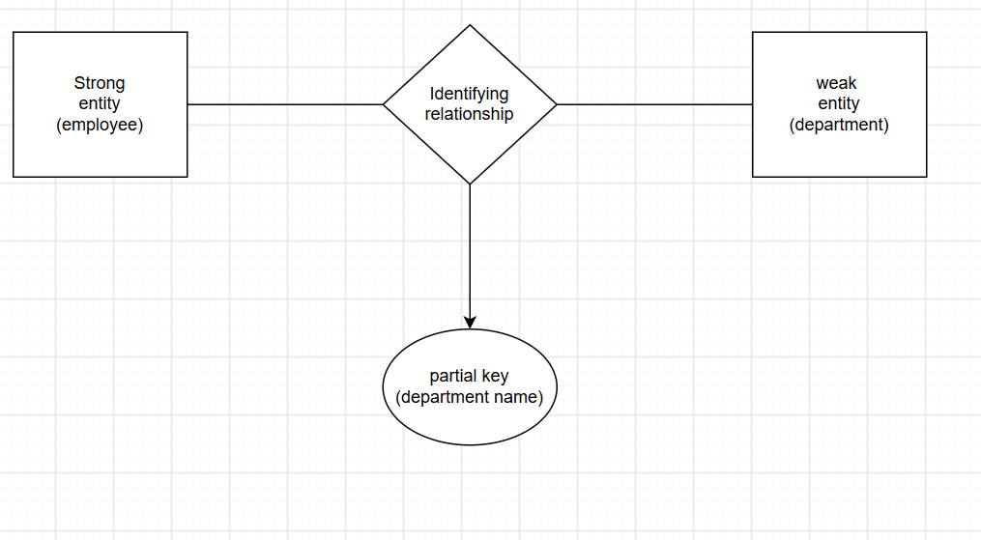

File-Based System
- Separate files
- Data redundancy
- Data inconsistency
- Poor security
- Difficult backup
- No concurrency control
↓
Problems
- Duplicate data
- Difficult maintenance
- Data isolation
- Limited sharing
↓
DBMS
- Centralized database
- Reduces redundancy
- Improves consistency
- Better security
- Backup and recovery
- Multi-user support
- Concurrency control

Q4. Design a concept map for ER diagram components: entity, weak entity, attribute types, relationship types, and participation constraints.

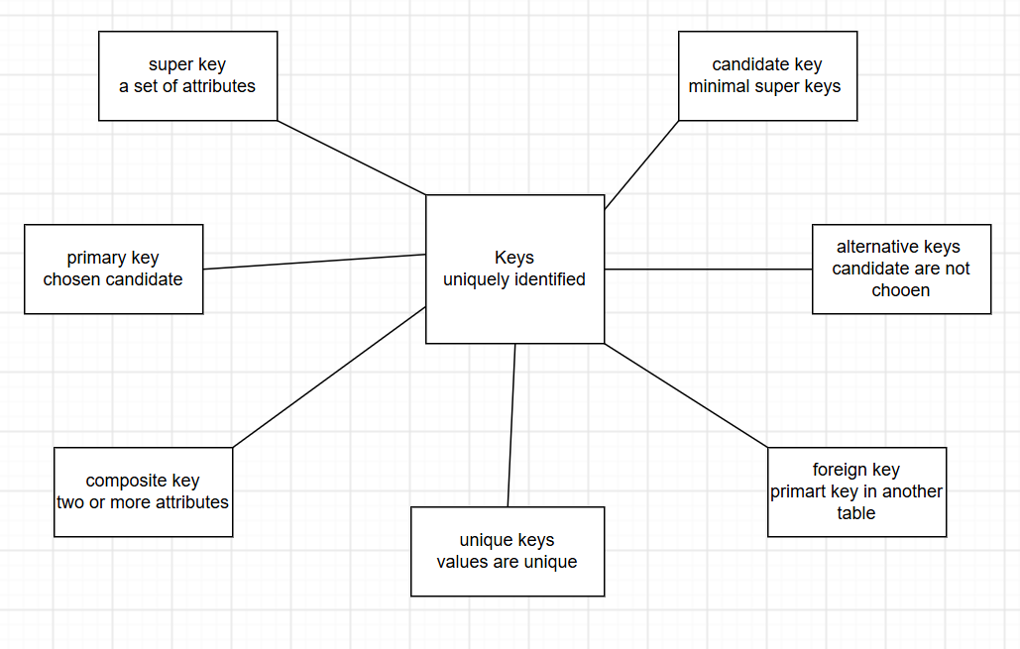
ER Diagram
↓
Entity
- Strong Entity
- Weak Entity
↓
Attributes
- Simple Attribute
- Composite Attribute
- Multivalued Attribute
- Derived Attribute
- Key Attribute
↓
Relationships
- One-to-One (1:1)
- One-to-Many (1:M)
- Many-to-Many (M:N)
↓
Participation Constraints
- Total Participation
- Partial Participation

Q5. Construct a concept map comparing Hierarchical, Network, and Relational data models with their key properties

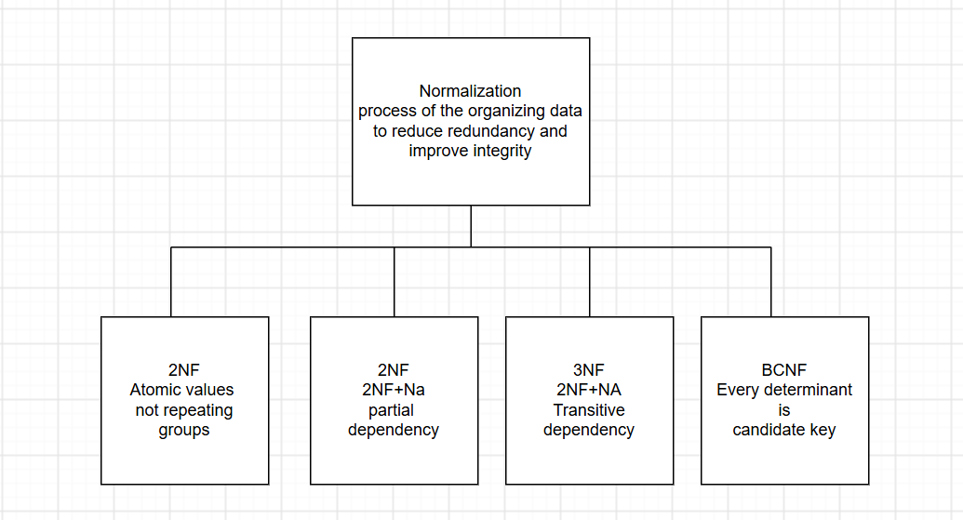

Data Models
↓
Hierarchical Model
- Tree Structure
- Parent-Child
- One-to-Many
- Fast traversal
↓
Network Model
- Graph Structure
- Many-to-Many
- Multiple Parents
↓
Relational Model
- Tables
- Rows
- Columns
- Primary Key
- Foreign Key
- SQL

